- Design web page as the following:
For this form change the following:
- Color and font size of labels.
- Change the distance between it and outside tags.

For this (div) change the following:
- Border(style, color, and thickness)
(10px inset white)
- Background color (gray)
- Change the position from top and left.
- (position: absolute, left:…, top:….)
- Change Width and height.

\

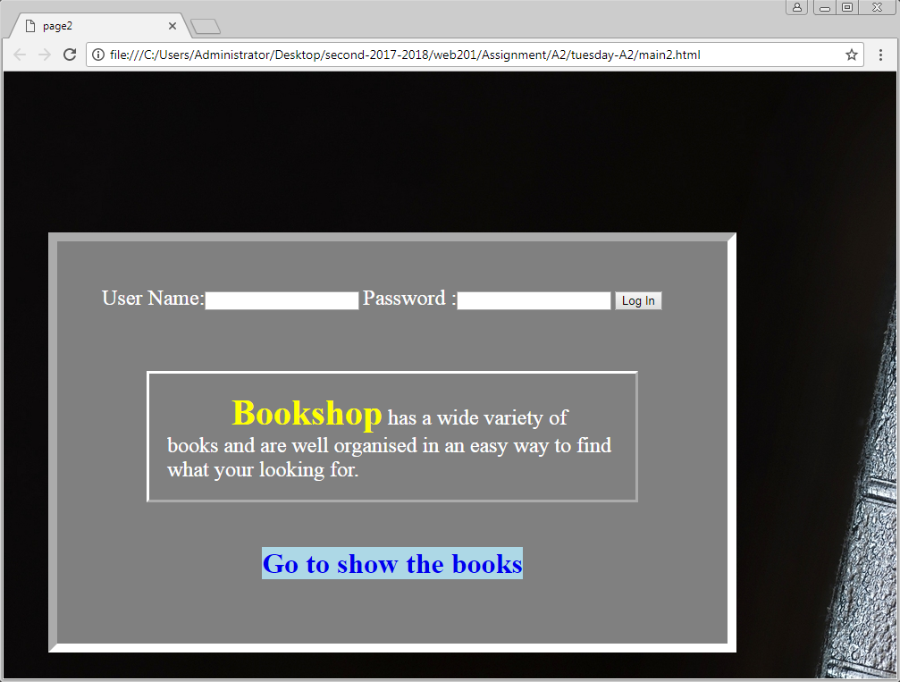
For this (p) changes the following:
- Font size (18pt) and color (white).
- For “Bookshop” word change the font size (30pt) and color also make it bold.
- Increase the distance between border and content.
- Increase the distance between border and outside tags.
- Border: 3px outset white

Change the background image of the page

For this (a) change the following:
- Hide the line under the link.
- Change the background color (lightblue)
- Change the alignment to center.

